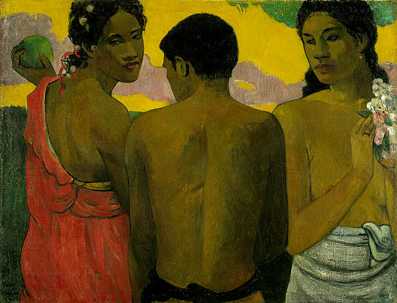
Anthropology 201:Cultural Anthropology

Professor: Dr. Stacey Rucas
Location: 10/227
Date/Time: 12:10-4pm M/W
Office Hours: Office Hours: M/W 10:50-12:10
Office Location 47/12B
Contact: o. (805)756-1374 c.(505) 453-8934 srucas@calpoly.edu

Required Text:
- Mirror on Humanity: a Concise Introduction to Cultural Anthropology by Conrad Kottak
- Several (6) Cultural Anthropology scientific articles in .pdf posted on the readings section of the course materials tab on Blackboard (titles listed below)

Course Description:
This course fulfills Cal Poly GE area D3 requirements. The major goal of this course is to introduce students to the theory, concepts and data of Cultural Anthropology. One of the most unique biological and behavioral features of our species is the capacity to produce language and culture. Students will be exposed to the variety and richness of human life in the past and contemporary worlds. This course introduces students to the concepts of culture, memetic theory, ethnographic method, and comparative social ideologies. Topics include worldwide variation in economics, political organization, gender rolls, sexuality, marriage customs, kinship, social stratification, religion, globalization, development. Focus will be placed on enhancing student skills of ethnographic analysis, cultural relativism and diversity awareness.

Learning Objectives:
- Understand and appreciate the cultural attributes of major world regions and the processes that shape cultural change and interaction, including international developmental and applied anthropological issues.
- Exposure to knowledge of human ecology with specific emphasis on ecological, demographic and epidemiological dimensions of human adaptation including evolutionary foundation over time and space.
- Learn to critically analyze issues from multiple cultural and behavioral perspectives and communicate results effectively.
- Exposure to synthesis of information and utilization of acquired skills in cultural anthropology to improve local and global human conditions through application of scientific methodology and technique.

Evaluation:
There will be two online exams that will count for 35% each of the final course grade. Exams will consist of multiple choice questions that will cover information from lectures, films, course texts, and special readings. Thirty percent of the grade will be attributed to a cultural anthropology food ways assignment (more will be discussed in class).

Attendance is not taken, but is essential to doing well in this class. Many exam questions will be taken directly from lectures and may not always be found in your books, articles or powerpoint slides. Also, makeup exams, either early or late, are not allowed in this class. All students are responsible for verifying that their online exams have been submitted successfully. In the event that there is a dispute regarding an online exam attempt or grade, the statistical electronic information in Blackboard will be considered the final say in the matter. Online exams are open note and open book, but they are not open for sharing of answers or discussion with other students. You are on your honor to execute your own work.
Important Note
It will not be possible to pass this class without the use of the course website. You will need to have a username and password and will login to Blackboard through the Cal Poly Portal. http://my.calpoly.edu. This website will host information and data for powerpoint lectures, calendar, email, exams and grades.

Course Schedule and Readings:

Week 1
The nature of anthropology
Concepts of culture, science and inquiry
A look at the “other”
Readings: Chapter 1
Article: Body Ritual Among the Nacirema by Horace Miner

Evolution of language and culture
Methods in cultural anthropology
Introduction to Cultural Relativity.
Readings: Chapters 3 and 4

Week 2
Applied anthropology
Special topics the new science of Medical Anthropology
Medical Tourism
Readings: Chapter 12
Article: The Viral Superhighway by G. Armelagos

Economics and subsistence
Making a living
Ecological impacts on behavior
Readings: Chapter 5
Articles:
- Strings Attached by Lee Cronk
- The Worst Mistake in the History of the Human Race by J. Diamond

Week 3
Ethnicity and Race
Kinship and Descent
Readings: Chapter 11
Article: White Privilege by P. McIntosh
EXAM I Due July 7th

Sex and Gender
Cross-cultural sexuality
Readings: Chapter 8
Article: Worthless Women by KA Pyburn

Week 4
Political Systems
Bands, Tribes, Chiefdoms and States
Social Stratification
Readings: Chapter 6

Ritual and supernatural beliefs
Increasing complexity of beliefs
Taboos, rites of passage, practitioners
Readings: Chapter 9

Week 5
Sex Roles Marriage and the family
Monogamy, polygyny, polyandry
Sexuality, marriage and divorce
Readings: Chapter 7
Article: Arranged Marriage in India by S.Nanda

Culture change and globalization
Homogenizing the world
Loss of cultural and linguistic diversity
Readings: Chapters 10 and 12
Film: Life and Debt in Jamaica

IMPORTANT SCHEDULING NOTES:
FOOD WAYS ASSIGNMENT IS DUE WED June 30th

If you have a disability for which you are or may be requesting an accommodation, you are encouraged to contact both your instructor and the Disability Resource Center, Building 124, Room 119, at (805) 756-1395, as early as possible in the term.

Final Exam during the last day of class Wed 7/21
Important Summer Scheduling Notes:
- No in-class meetings on Monday July 5th (Independence Day Observed)

